ST. MARIES FIRE PROTECTION DISTRICT
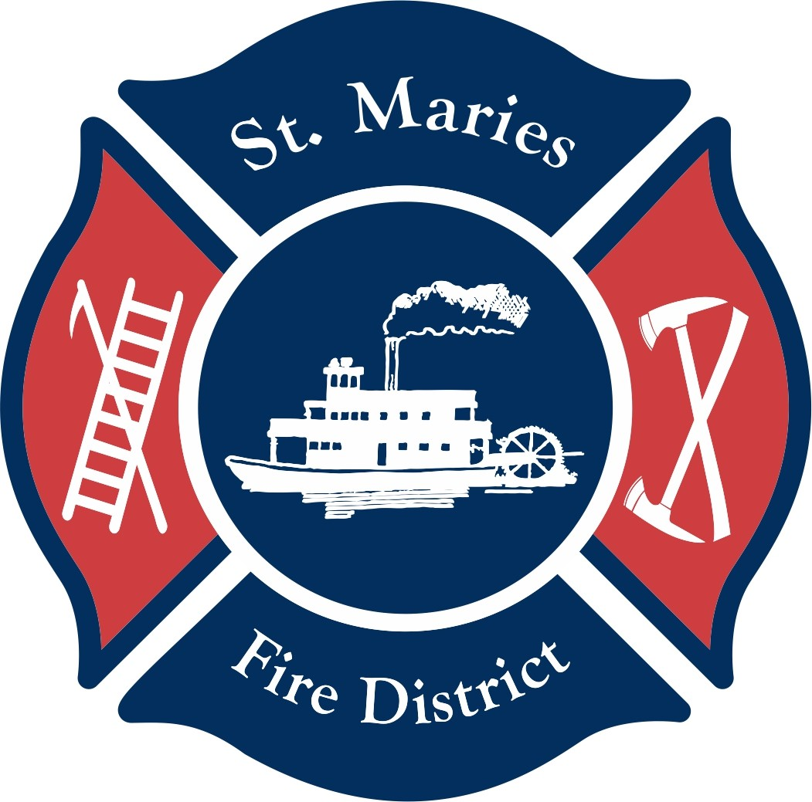
308 W. Jefferson Avenue, St. Maries, ID. 83861
Phone (208) 245-5253 – Fax (208) 245-2328

2026 Burning Requirements

Burn permits are required at all times in Saint Maries city limits. A Copy of these burning regulations and your burning permit must be on site at all times while burning. Please obtain a new copy of the burn requirements yearly, as burning restrictions may have changed.
Burn permits shall be issued only after a site has been inspected, and approved by a fire district member, the burn permit duration shall last no more than ten (10) days from the date of issuing. Burn permit renewals will only be issued after, or on the expiration date of the current permit, and after the site has been inspected and approved by a fire district member.
Contact the St. Maries Fire District at 208-245-5253 or the Idaho Department of Lands Office (IDL) at 208-245-4551 for information of burning closures. Burning may be closed certain times of the year by the IDL, St. Maries Fire Protection District, or Idaho DEQ based on hazardous fire conditions or poor air quality under Idaho code.
Contact Benewah County Dispatch office at 208-245-2555 to notify of any controlled burning even if a permit has been issued.
Burning is only permitted when the Idaho Department of Environmental Quality (DEQ) has the air quality level at Green. Burning with Yellow or Red air quality condition is prohibited.
Burning outside of the St. Maries city limits must be in accordance with the Idaho Department of Lands (IDL) requirements. The IDL requires burn permits from May 10th to October 20th. Burn permits may be obtained using the IDL online permitting process at http://burnpermits.idaho.gov/Home.aspx. Please contact the IDL West St. Joe Fire District Office at 208-245-4551. IDL burn permits are free to obtain.
Burning is allowed or prohibited as directed by IDL Stage 1 and Stage 2 restrictions, even if the DEQ air quality is rated at green.

- Residential Yard Waste Burning
- Burning of yard waste is permitted during daylight hours only (sunrise to sunset).
- Residential yard waste is defined as clean untreated wood, paper, dry vegetation, limbs and branches.
- The burning of wet vegetation, such as leaves, needles, limbs, and branches is prohibited.
- Fires must be attended at all times. A water source, a water or dry chemical fire extinguisher, and a shovel must be at the burn sites at all times.
- Burn permits will be issued to property owners and legal occupants only.
- All yard waste fires must be minimum of 50 feet away from all structures, stacked firewood, fences, and electrical and propane utilities to prevent the ignition of combustible materials.
- Burning of any trash, manure, animal parts, treated lumber, plastic, tires, household garbage, pallets, painted materials, and other hazardous materials is prohibited.
- Burn barrels are prohibited within the St. Maries Fire Protection District coverage area.
- Fire district and law enforcement officials are authorized to require burning to be discontinued, and the fire extinguished, if the smoke emissions or odors are offensive to occupants, or surrounding properties, or if the burning is deemed unsafe, or if the DEQ air quality determination changes to yellow or red.
- Burning is allowed or prohibited as directed by IDL Stage 1 and Stage 2 restrictions.

- Recreational Burning
- Recreational burning is defined as small cooking fires, campfires, and warming fires no larger than 3 feet in diameter and 2 feet tall.
- Recreational fires are allowed during day or night but must be fully extinguished and cold to the touch.
- Bonfires of any size require a permit.
- Burn permits are not required for use of a portable, factory built, outdoor wood burning fireplaces, or permanently installed outdoor wood burning fire pits.
- Any structure used for outdoor fires that was not originally constructed to be used for wood burning, requires an inspection and approval by the fire code official or designee. Once approved that structure does not require a burn permit for recreational fires.
- All outdoor fireplaces and fire pits are subject to inspection as deemed necessary by the fire code official or designee. Burn barrels are prohibited.
- All recreational fires must be a minimum of 25 feet away from all structures, trees, fences, stacked firewood, and electrical and propane utilities to prevent the ignition of combustible materials. Recreational fires may be within 25 feet of structures or combustible materials, if they are contained within a barbecue pit.
- Recreational fires must be attended at all times. A water source, a water or dry chemical extinguisher, and a shovel must be at the burn sites at all times.
- Burning is allowed or prohibited as directed by IDL Stage 1 and Stage 2 restrictions.

- Commercial and/or Slash Pile burning
- Burning outside of the St. Maries city limits is regulated by the IDL.
- All open burning, except small recreational fires, requires an Idaho Department of Lands (IDL) burn permit. IDL Burn permits can be obtained by going to http://burnpermits.idaho.gov/Home.aspx. For the IDL West St. Joe Fire District Office call 208-245-4551. Permits are valid for ten (10) days, but can be renewed by logging back into the IDL burn permit website.
- All fires must be attended at all times, fires must be completely extinguished before you leave the site, with the exception of Logging slash piles which may be allowed to burn unattended, and throughout the night, when conditions allow.
- All burning must follow the IDL burn permit requirements. Logging slash piles, machine generated piles, and field burning must meet Idaho Department of Lands Guidelines.
- Burning of construction debris by contractors and commercial trade waste is prohibited by the State of Idaho Department of Environmental Quality.
- Hauling of debris from one property to another to burn is prohibited.
- Small warming fires during cold weather are allowed but shall be contained, shall involve clean lumber only (no glued products) and shall be completely extinguished before leaving the site.

- Information for Safe Burning
- Prior to issuing a burn permit, fire district personnel shall visit the burn location to check for hazards.
- A fire safety break should be created to prevent the spread of fire to nearby combustible materials. Fire safety breaks consist of the ground cleared down to mineral soil, and no vegetation or trees are in close proximity to the fire area. Fire safety breaks should be 10-foot minimum clearance around recreational fires. Bonfires and other large burns should have minimum clearance of 2 times the diameter of the burn area.
- You are responsible for your fire. Fires must be attended at all times by a responsible adult with adequate tools and equipment to keep the fire contained and under control.
- Open burning that will be or is offensive or objectionable due to smoke or odor emissions, shall be prohibited by the fire official or designee. Open burning that is hazardous due to atmospheric conditions, or when smoke or odor complaints from the public are being received, may be required by a fire official or law enforcement officer to be discontinued and the fire extinguished.
- Check the fire danger and air quality index each day before you burn. Do not burn during windy conditions. If your fire escapes your burn area, you are responsible for extinguishment costs and damages.
- Failure to comply with the burning requirements listed herein, and those listed in the Idaho Department of Lands guidelines, may result in the burn permit being revoked and future burn permits being denied. Failure to comply with the burning requirements may also result in fines issued by the Idaho Department of Environmental Quality (IDEQ) and/or being charged with extinguishment costs.

- City Limit special considerations
- Prohibited zone: There is an established zone within the city where there shall be no burning of trash or debris whatsoever at any time within the year and said zone.
- The above-mentioned zone is described as follows: From the north side of College Avenue to the west side of Eleventh Street to the east side of Third Street; thence one block south to the north side of Jefferson Avenue, and east to the east side of First Street; thence north to the south side of Milwaukee Railroad; thence west to the west side of Eleventh Street; thence south to the north side of College Avenue.
- A map of the zone is attached to this permit for ease of reference.

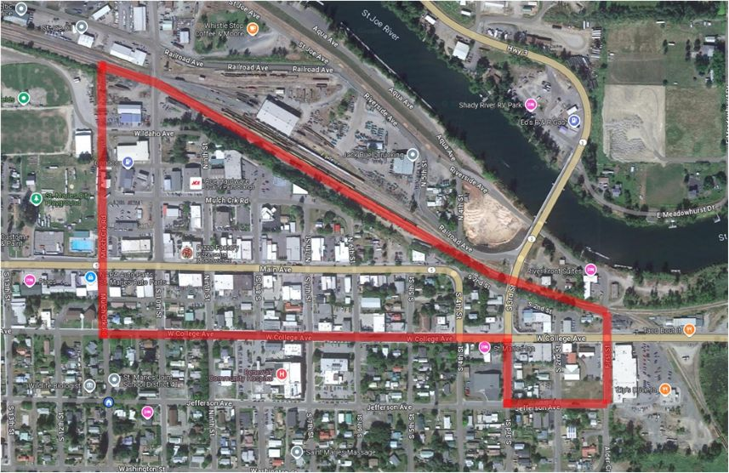

Authorized By St. Maries Fire Protection District, Chief Michael Patti

